Elisha Parslow

CS373 Database Management

HW3

**EX03_01**

7.5. Specify the following queries on the database in Figure 5.5 in SQL. Show the query results if each query is applied to the database state in Figure 5.6.

a. For each department whose average employee salary is more than $30,000, retrieve the department name and the number of employees working for that department.

SELECT d.Dname, Count(*)

FROM Department d, Employee e

WHERE e.Dno = d.Dnumber

GROUP BY d.Dname

HAVING AVG(e.Salary) > 30000;

b. Suppose that we want the number of male employees in each department making more than $30,000, rather than all employees (as in Exer- cise 7.5a). Can we specify this query in SQL? Why or why not?

Yes, you can specify male because there is the option to count the number of employees with a specific gender.

SELECT d.Dname, Count(*)

FROM Department d, Employee e  
WHERE e.Sex = ‘M’ AND e.Dno = d.Dnumber and Dno IN (SELECT Dno

FROM Employee e

GROUP BY Dno

HAVING AVG(e.Salary) > 30000)

GROUP BY d.Dname;

**EX03_02**

7.6. Specify the following queries in SQL on the database schema in Figure 1.2.

a. Retrieve the names and major departments of all straight-A students (students who have a grade of A in all their courses).

SELECT s.Name, c.Departnement   
 FROM Student s, Course c, Grade_Report g

WHERE NOT EXISTS (SELECT *

FROM Grade_Report g, Student s

WHERE s.StudentNumber = g.StudentNumber AND NOT Grade = ‘A’)

b. Retrieve the names and major departments of all students who do not have a grade of A in any of their courses.

SELECT s.Name, c.Departnement   
 FROM Student s, Course c, Grade_Report g

WHERE NOT EXISTS (SELECT *

FROM Grade_Report g, Student s

WHERE s.StudentNumber = g.StudentNumber AND Grade = ‘A’)

**EX03_03**

7.7. In SQL, specify the following queries on the database in Figure 5.5 using the concept of nested queries and other concepts described in this chapter.

a. Retrieve the names of all employees who work in the department that has the employee with the highest salary among all employees.

SELECT LName

FROM Employee

WHERE Dno = (SELECT Dno

FROM Employee

WHERE Salary = (SELECT MAX(Salary)

FROM Employee));

b. Retrieve the names of all employees whose supervisor’s supervisor has ‘888665555’ for Ssn.

SELECT e.LName  
 FROM Employee e   
 WHERE e.Superssn IN (SELECT e.Ssn

FROM Employee e

WHERE Superssn = ‘888665555’)

c. Retrieve the names of employees who make at least $10,000 more than the employee who is paid the least in the company.

SELECT e.Lname  
 FROM Emplyee e   
 WHERE Salary = 10000 + (SELECT MIN(Salary)

FROM Employee);

**EX03_04**

Output the last name, address and zip code of tall of the people who have a property type that is a professor or a visitor.

**EX03_05**

Output all of the information of people named George who have a return date that is sooner than March 19. 1993.

**EX03_06**

SELECT *

FROM dbo.Person

Where City = 'London';

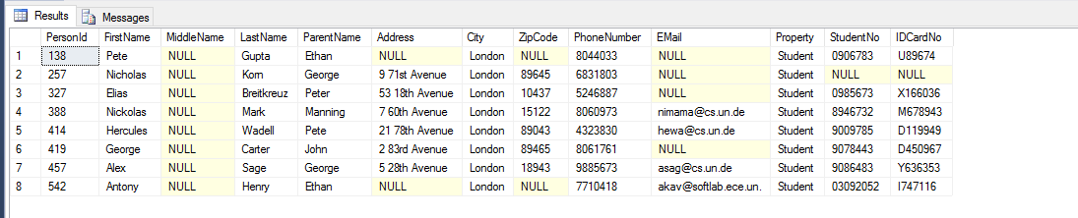

**EX03_07**

SELECT FirstName, LastName

FROM dbo.Person, dbo.Action

Where ReturnDate > DueDate;

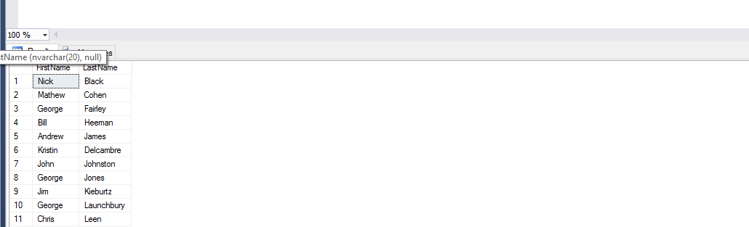

**EX03_08**

π

σ

Ω

**EX03_09**